THE HISTORY OF ŠKOFJA LOKA
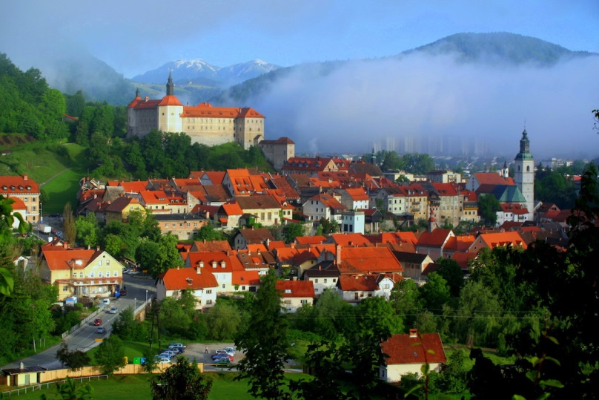
The history of Škofja Loka begins in the year 973, when Emperor Oton II. granted the territory of Loka to the bishop of Freising Abraham in feud. But this was not today's Škofja Loka, but as now known - Stara Loka. This was established by the bishops as their administrative and economic center was at a strategically important junction. Škofja Loka was first mentioned as a square in 1248 and 1274 as a city. Records indicate that Škofja Loka was firstly surrounded by the city walls in the 14th century. It was surrounded with five deffensive towers and five city gates. It had its one city autonomy.
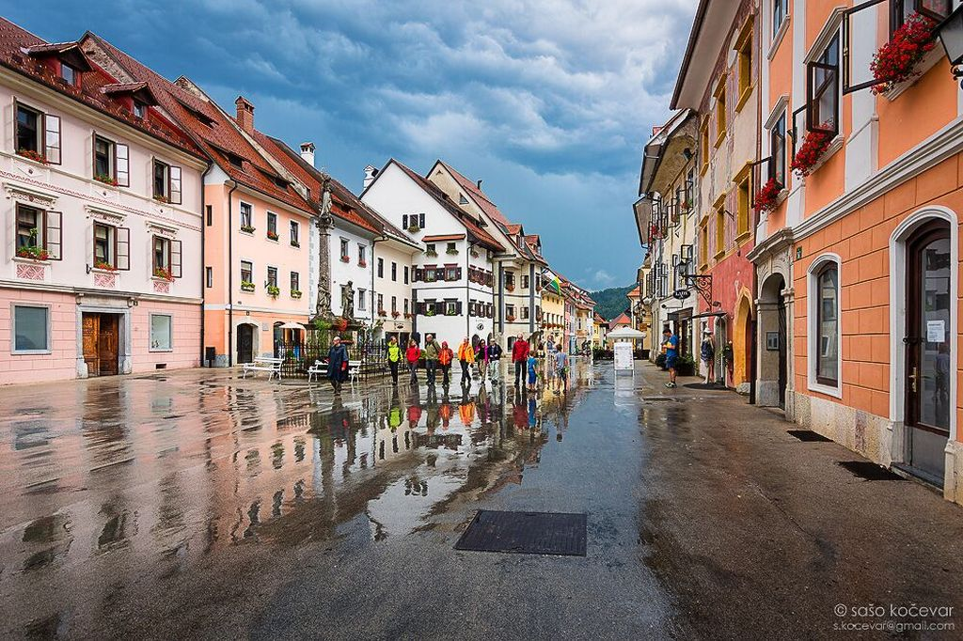
The old city center
In 1475, Jan Vitovec Celje's bishops commander invaved in the city and burned Škofja Loka to the ground. In 1476 the city was attacked by the Turks. The plague ravaged the city several times. Škofja loka collapsed in 1511 because of an earth quake that came from Idrija (on the south west). The landlord of that time- bishop Filip, rebuilt the city and some buildings are still standing on that same spot. Only Krancelj tower remained in ruins. The fires in 1660 and in 1698 were devestating for Škofja Loka, they left some visible consequences.
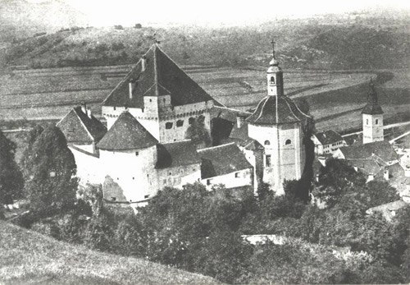
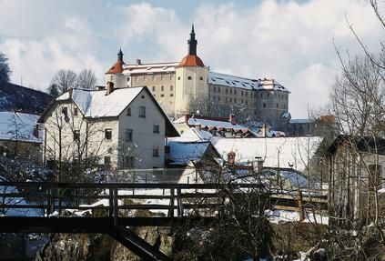
The castle in Škofja Loka used to have a central tower.

The castle in Škofja Loka today.
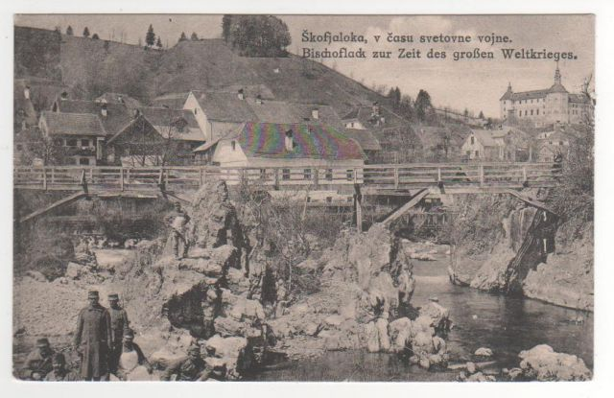
Devil‘s bridge in WWII
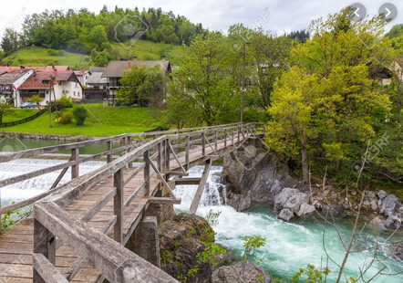
Devil‘s bridge today

After that the city didn't change that much. In 1789 they demolished the city walls and tored down the towers. Crafts and commerce were heavily developed in the Middle Ages. Under the stone bridge there is a mill standing from 1309. There were many blacksmiths, shoemakers, tailors, bakers and even more. In 1673 there were 93 craftmans in Škofja Loka. They were organized in handicrafts guilts that were at their height in the 17th century. There was a lively trade in iron, canvas and even in sieve. In 1803 Škofja Loka was annexed to the Austrian Province of Carniola. Škofja Loka was the first city in Carniola that got electric lights before the earthquake in 1895.

During the world war II, Škofja Loka was occupied by Italian forces but later on it was replaced by the German army. Škofja Loka has one of the best preserved medieval town centers in Slovenia. In 1987, the city was declared as a ultumonument.

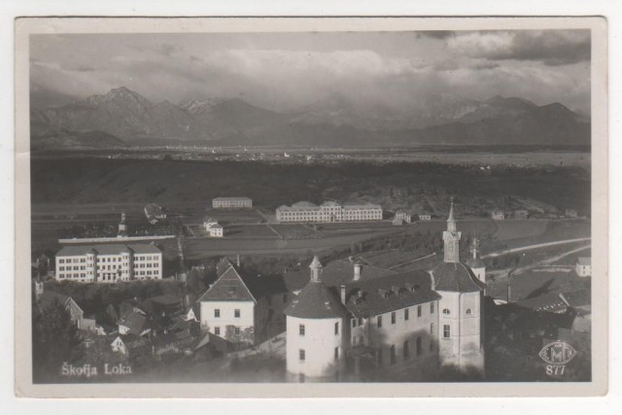
Škofja loka after WWII.
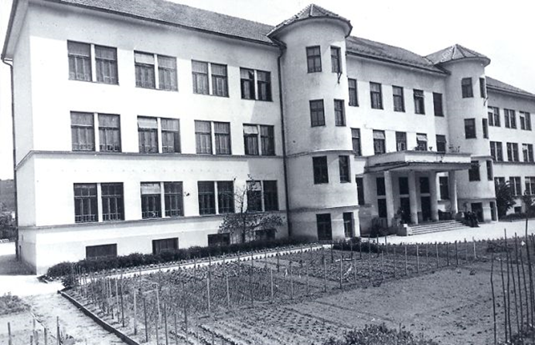
School garden before the renovation.
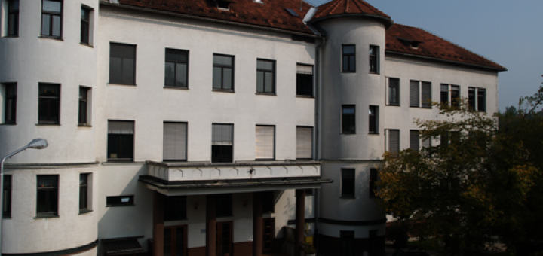
Our school today

Pupils and teachers of Primary school Škofja Loka-Mesto with the help of Internet .

