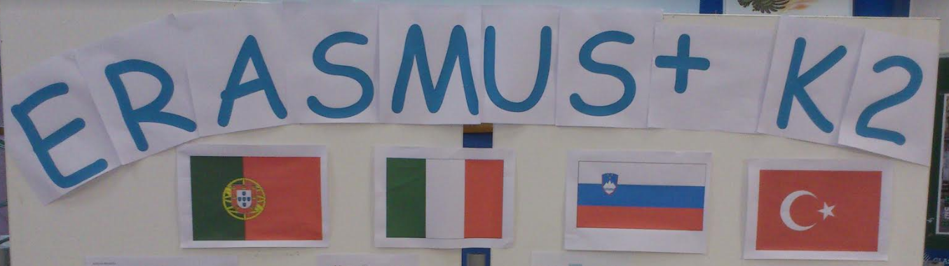
SLOVENIA
ITALY
TURKEY
SPAIN

PARTICIPATED COUNTRIES IN ERASMUS+ K2

I’M COLLABORATING WITH ICT FOR MY SCHOOL

ERASMUS CORNER AT OUR SCHOOL ŠKOFJA LOKA – MESTO

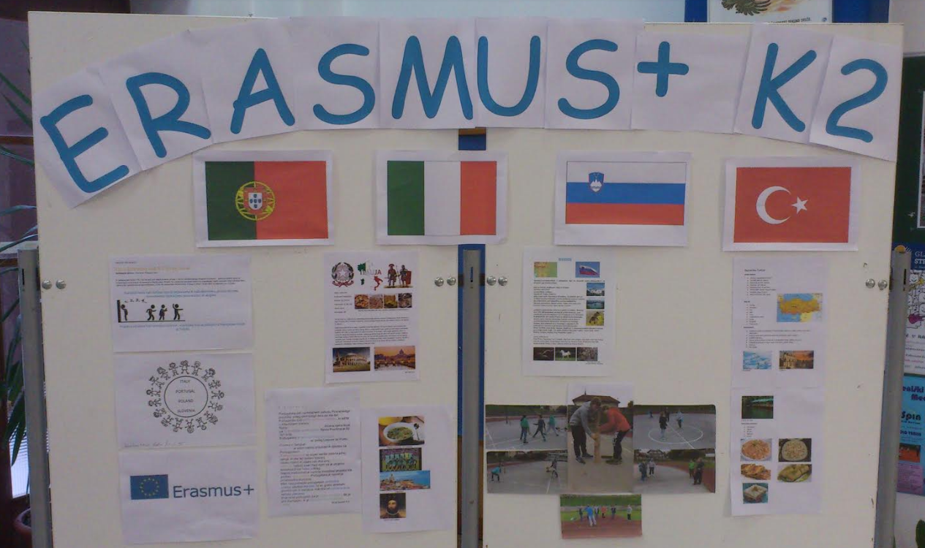
PUPILS WERE EXPLORING THE PARTICIPATED COUNTRIES
TRYING TO FIND OUT THEIR MAIN CHARACTERISTICS

GIVING BASIC INFORMATION AND INSTRUCTIONS ABOUT MAKING A LOGOTYPE OF OUR PROJECT

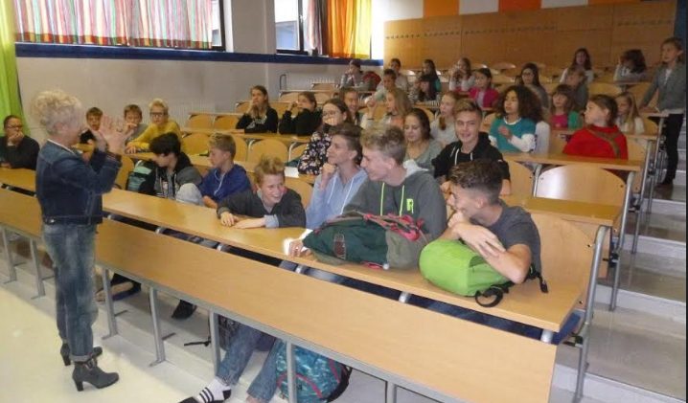 | 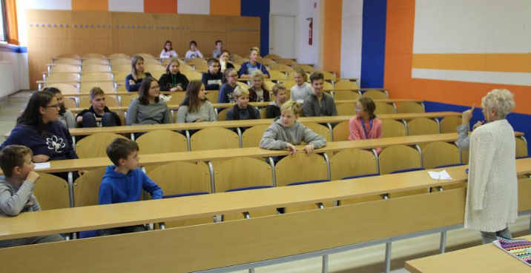

OUR PUPILS WHO LIKE DRAWING MADE THE FIRST LOGOTYPES
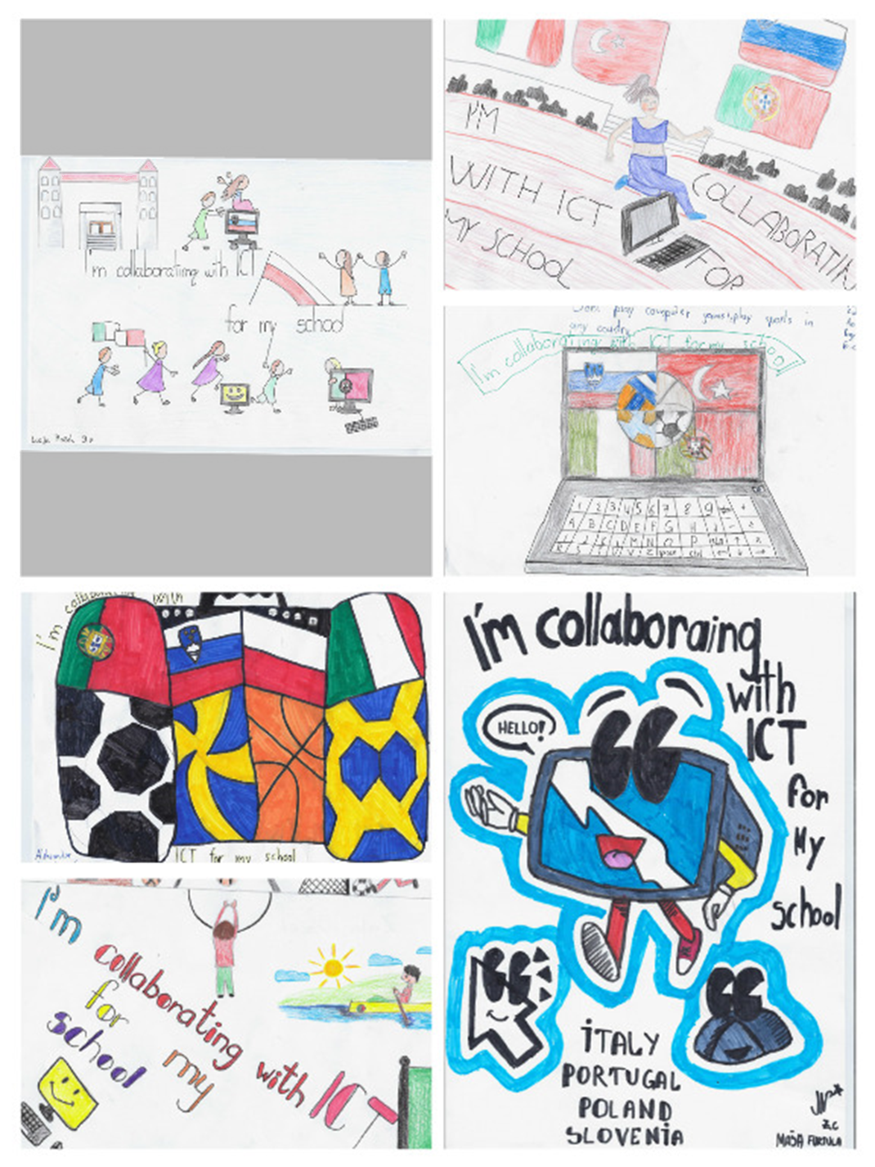
OTHER LOGOTYPES ARE AVAILABLE ON SCHOOL WEBSITE

ART TEACHER MAJA AND HER PUPILS ARE CREATING OUR LOGOTYPES
